Summary
In this third Roll-a-ball lab, you’ll:
- Set the Camera position
- Write a script to make the Camera follow the Player sphere with a fixed offset
1. Overview
In this lab, you’ll:
- Set the Camera position
- Write a script to make the Camera follow the Player sphere with a fixed offset
2. Set the Camera position
Follow the video or text instructions below to raise and rotate the camera, then experiment with the Player GameObject as a parent GameObject:
1. Raise and rotate the camera.
- Select the Main Camera in the Hierarchy window.
- Set the Y position value to around 10.
- Set the X rotation value to around 45.
- Preview the camera angle in the Game view.
2. Experiment with the Player as a parent GameObject.
- If you want, drag the Main Camera onto the Player GameObject in the Hierarchy window to set the camera as a child GameObject of the Player GameObject.
- Test the game and notice how the camera rotates with the movement of the Player GameObject.
- Undo the parent-child relationship by dragging the Main Camera above the Player GameObject.

Note: When the player is the parent of the camera in Unity, the camera rotates with the player because transforms inherit the rotation of their parent object.
Why It Happens
- Parent-Child Hierarchy: In Unity, child objects move and rotate along with their parent.
- Player Turning: When your script turns the player left or right (changing its Y rotation), the camera is attached to that transform.
- Camera Follows: The camera shares that same space. It turns right along with the player's body instead of staying still or looking around independently.
How to Fix It
To stop the camera from spinning with the player's body:
- Unparent the Camera: Make the camera an independent object in the hierarchy (not a child of the player).

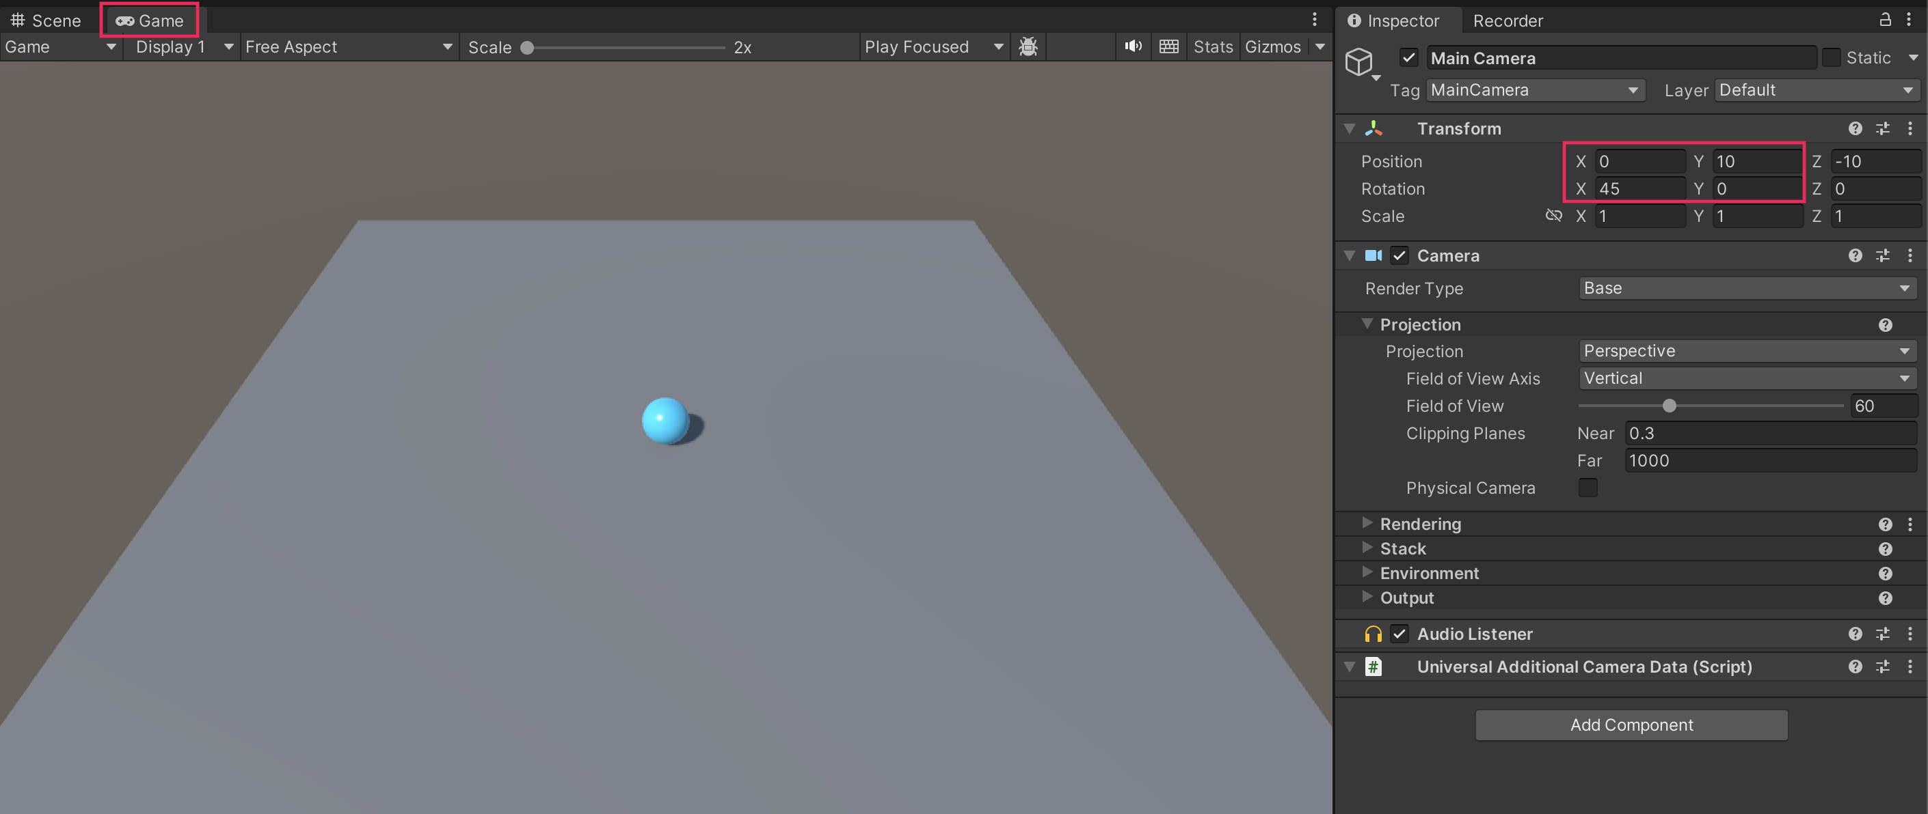
3. Write a CameraController script
1. Create the CameraController script.
- With the Main Camera GameObject selected in the Hierarchy window, select Add Component > New script in the Inspector window.
- Name your new script “CameraController”.
- In the Project window, move the script from the root Assets folder into the Scripts folder.
- Open the new script for editing.
2. Declare player and offset variables.
- Inside the first curly brace, add the following lines of code to declare two new variables:
public GameObject player;
private Vector3 offset;
3. Define the offset variable.
- In the Start function, on a new line after the first curly brace, add the following line of code:
offset = transform.position - player.transform.position;
4. Set the camera position in LateUpdate.
- In the Update function, inside the first curly brace, add the following line of code:
transform.position = player.transform.position + offset;
- Change the Update function to a LateUpdate function:
void LateUpdate()
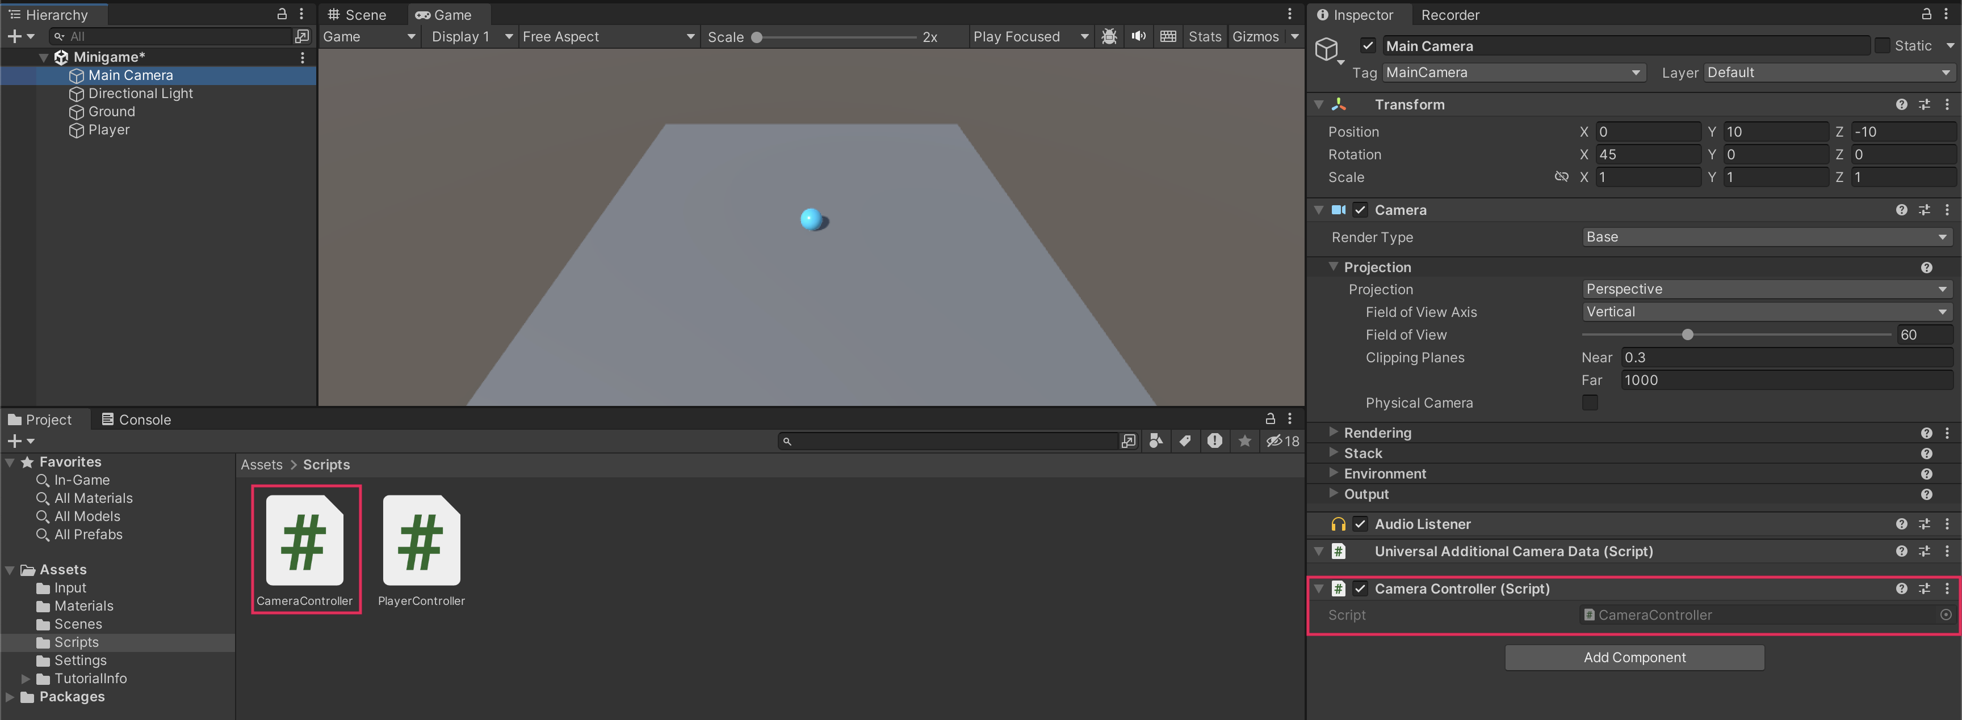
4. Reference the Player GameObject

1. Assign the Player GameObject variable in the Inspector window.
- Make sure you have saved the CameraController script, then return to Unity.
- In the Hierarchy select the MainCamera GameObject, then drag the Player GameObject from the Hierarchy window into the Player slot in the CameraController component.
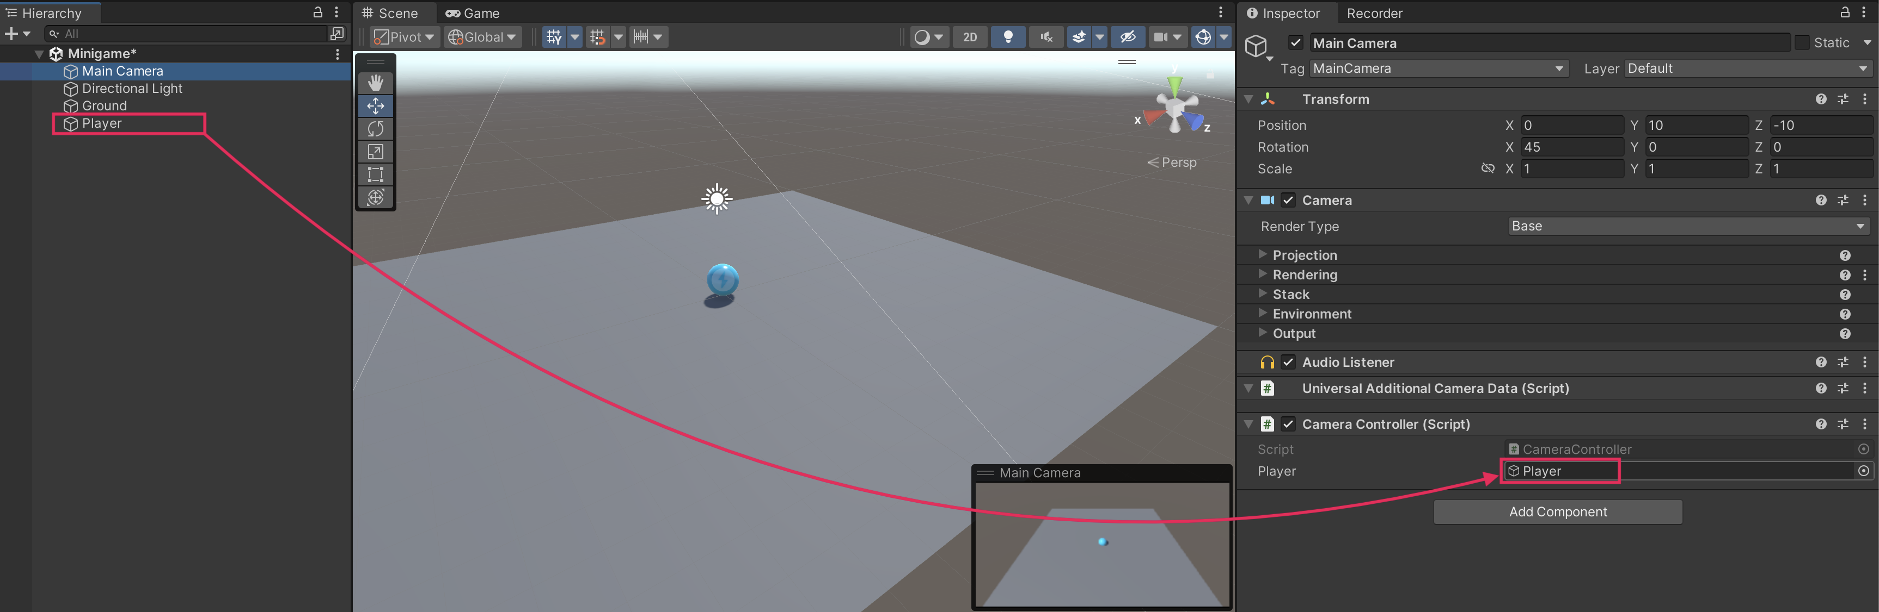
2. Test the game.
- The camera should now follow the player at the appropriate offset.
5. Final script sample

If your script is not working as expected, below is an example of what your code should look like at this point. The comments have been added to make the code more readable.
CameraController.cs
using System.Collections;
using System.Collections.Generic;
using UnityEngine;

public class CameraController : MonoBehaviour
{
// Reference to the player GameObject.
public GameObject player;

// The distance between the camera and the player.
private Vector3 offset;

// Start is called before the first frame update.
void Start()
{
// Calculate the initial offset between the camera's position and the player's position.
offset = transform.position - player.transform.position;
}

// LateUpdate is called once per frame after all Update functions have been completed.
void LateUpdate()
{
// Maintain the same offset between the camera and player throughout the game.
transform.position = player.transform.position + offset;
}
}

